SCENARIO

You are an electrical technician in an electronics factory. Your supervisor asked you to work on solving some practical issues in different types of circuits that you are used in the products. Try to use your knowledge about circuit theory and transformation techniques to simplify and solve those problems.

To achieve the assessment criteria for pass (P1.1) you must answer the following tasks

Task 1:
Use transformation theorems (i.e. Norton or Thévenin; Delta Star) to calculate the required circuit parameters as follows:
- For the figure below calculate:
  - Mention to the applied theory in your answer.
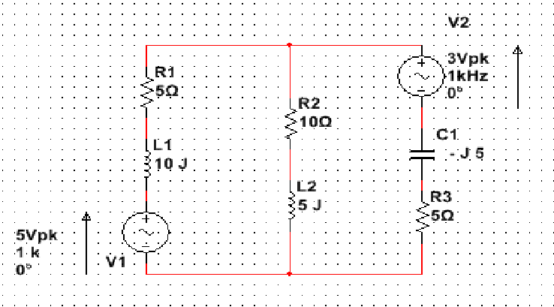
  - The current through R2 and L2.
  - The voltage drop across R2.

- For the figure below calculate:
  - Mention to the applied theory in your answer.
  - Total circuit impedance.
  - Supply current

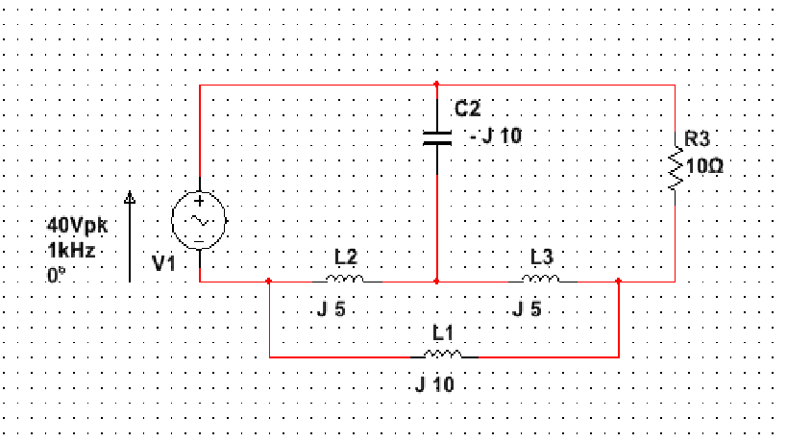

To achieve the assessment criteria for pass (P1.2 part 1/2) you must answer the following task:

Task 2:

Apply circuit theory techniques (i.e. Max power, Mesh or Nodal, Super position) to solve the following problem

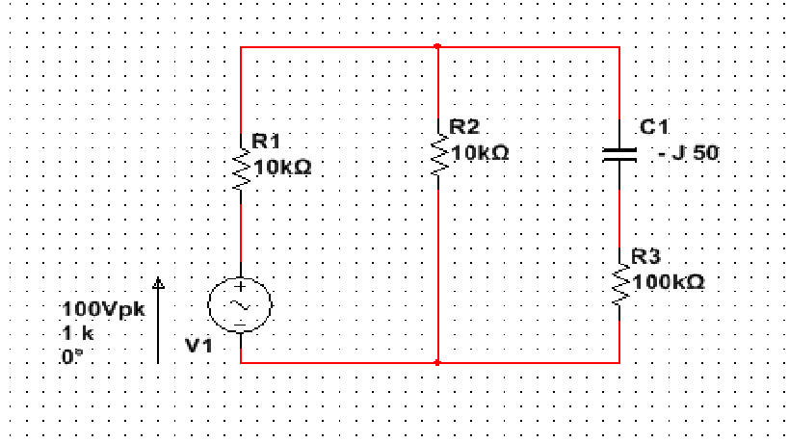
The above circuit is a part from television receiver circuit and the branch (C1 and R3) is a critical part and we need to know:
- The rated power for R3 to be used.
- The rated voltage for C1 to be used, to ensure normal operation for long time without the receiver gets damaged.

To achieve the assessment criteria for pass (P1.4 part 1/2) you must answer the following task:

Task 3:

A practical filter part of TV receiver is designed to operate at 10 k Hz as a resonance frequency with series RLC connected. The series capacitor is accidently damaged and we did not know its value, while the resistance equal to 1 k Ω and the inductor with 15 mH,
Use circuit theory to solve such a problem to get the value of the capacitor and then ensure your solution by finding:
- The total impedance at resonance with the phase angle.
- The total impedance at fr/2 with the phase angle.
- The quality factor.
- The bandwidth of the filter.
- Finally comment on the filter selectivity.

